Retro Game Documentation

Git repo- <https://github.com/JasonAnderson0/IntroToCPP_Assessment>

For the Retro Game aspect of the Introduction to C++ assessment I decided to recreate the classic arcade game Asteroids that was released in 1979.

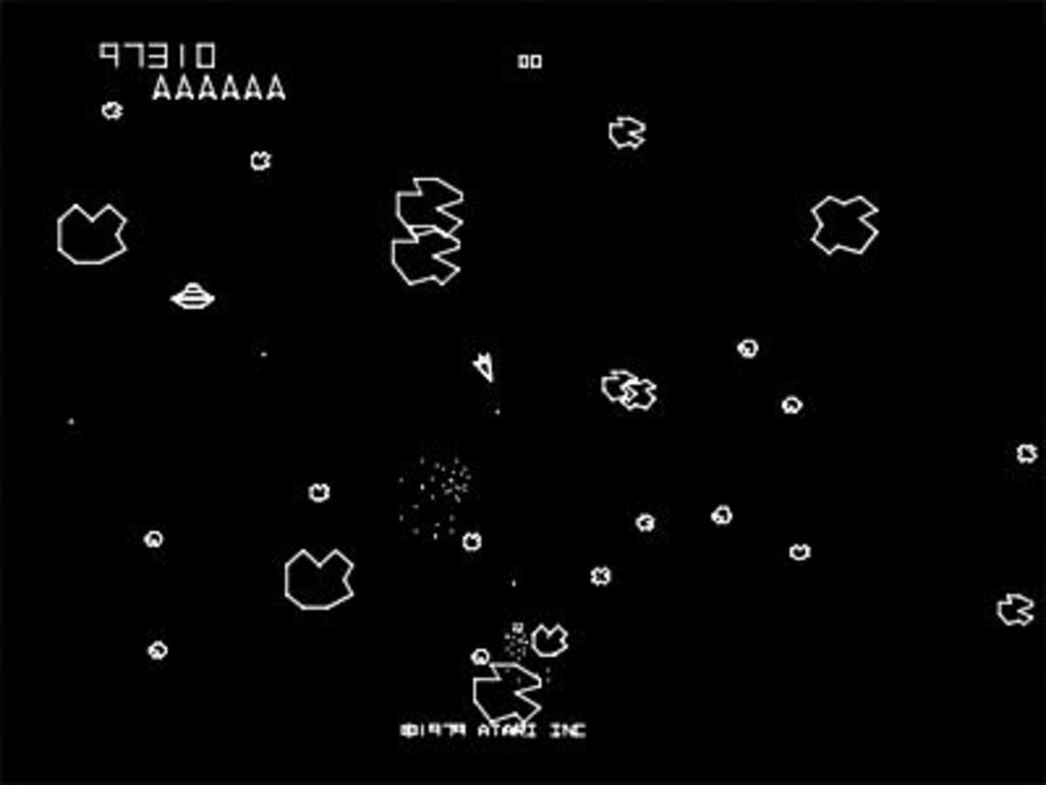

Each game object is inheriting properties and functions from a base class that makes it easier to write the code for each different object without needing to repeat anything while also allowing those inherited variables and functions to be overwritten as needed. The most common functions that all objects used were the update function and the draw function. Each object that was used had to be drawn using raylib, so it used the draw function to load the sprite into the application. Also, every object had code that it had to execute each frame, whether it was the ship checking the players input or the asteroid checking if it is colliding with a bullet.

The only collisions that needed to be implemented were between each asteroid and the ship, as well as each asteroid and each bullet as there shouldn’t be any interaction between the ship and any bullets. Therefore it was easiest to have the math for the collisions worked out within the asteroid script as that is the main object that uses collisions. Each object was mostly circular, so it made sense to have a radius around each object that is used to detect collisions. The method for working out collisions is done by first calculating the distance between the two objects to check how far away they are and then considering their collisions radius’ to see if they are overlapping, which would constitute as colliding.

Finished Product:

